UNION TERRITORY EXAMS

Ser No | State | Category of Exam | Conducting Body | Ser No | Name of the Examination | Website | Logo
1 | Andaman and Nicobar Islands | SSC | Staff Selection Commission | 1 | SSC CGL  (Combined Graduate Level) | https://ssc.gov.in | 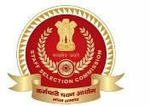
 |  |  |  | 2 | SSC CHSL  (Combined Higher Secondary Level) | https://ssc.gov.in | 
 |  | BANKING | Institute of Banking Personnel Selection (IBPS) | 3 | IBPS RRB PO | https://www.ibps.in | 
 |  |  | IBPS | 4 | IBPS Clerk / PO / RRB | https://www.ibps.in/ | 
 |  |  | SBI | 5 | SBI PO / Clerk | https://sbi.co.in/web/careers | 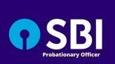
 |  | ADMINISTRATIVE | A&N Administration | 6 | Combined Graduate Level Exam | https://andaman.gov.in/ | 
 |  |  | A&N Administration | 7 | Lower Division Clerk (LDC) | https://andaman.gov.in/ | 
 |  |  | A&N Administration | 8 | Upper Division Clerk (UDC) | https://andaman.gov.in/ | 
 |  |  | A&N Administration | 9 | Junior Secretariat Assistant / Stenographer | https://andaman.gov.in/ | 

 |  | POLICE | A&N Police | 10 | Police Constable | https://police.andaman.gov.in/ | 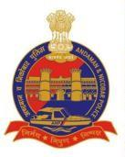
 |  |  | A&N Police | 11 | Sub-Inspector | https://police.andaman.gov.in/ | 
 |  |  | A&N Jail Department | 12 | Warders / Jail Staff | https://police.andaman.gov.in/ | 
 |  | Fire Services | A&N Fire Service | 13 | Fireman / Driver Operator | https://police.andaman.gov.in/ | 
 |  | Teaching | Education Dept A&N | 14 | Primary Teacher | https://andaman.gov.in/ | 
 |  |  | Education Dept A&N | 15 | Graduate Teacher (GT) | https://andaman.gov.in/ | 
 |  |  | Education Dept A&N | 16 | Post Graduate Teacher (PGT) | https://andaman.gov.in/ | 
 |  | Medical | Health Dept A&N | 17 | Medical Officer / Specialist | https://andaman.gov.in/ | 

 |  |  | Health Dept A&N | 18 | Staff Nurse | https://andaman.gov.in/ | 
 |  |  | Health Dept A&N | 19 | Pharmacist | https://andaman.gov.in/ | 
 |  |  | Health Dept A&N | 20 | ANM / Lab Technician / Radiographer | https://andaman.gov.in/ | 
 |  |  | NHM A&N | 21 | Contract Medical & Admin Staff | https://andaman.gov.in/ | 
 |  | Teaching | Education Dept A&N | 22 | Primary Teacher | https://andaman.gov.in/ | 
 |  |  | Education Dept A&N | 23 | Graduate Teacher (GT) | https://andaman.gov.in/ | 
 |  |  | Education Dept A&N | 24 | Post Graduate Teacher (PGT) | https://andaman.gov.in/ | 
 |  |  | AN College / Govt Colleges | 25 | Assistant Professor / Lecturer | https://andaman.gov.in/ | 
 |  | Engineering | APWD | 26 | Junior Engineer (Civil/Electrical) | https://apwd.and.nic.in/ | 

 |  |  | APWD | 27 | Assistant Engineer | https://apwd.and.nic.in/ | 
 |  |  | Electricity Dept | 28 | Electrician / Lineman / JE | https://andaman.gov.in/ | 
 |  | Marine Services | Directorate of Shipping Services | 29 | Marine Engineer / Seaman / Boat Crew | https://dss.andaman.gov.in/ | 
 |  | Transport | Transport Dept A&N | 30 | Motor Vehicle Inspector / Inspector | https://andaman.gov.in/ | 
 |  | Ports | Port Management Board | 31 | Port Staff / Technical Recruitment | https://andaman.gov.in/ | 
 |  | Forest | Forest Dept A&N | 32 | Forest Guard / Forester | https://andaman.gov.in/ | 
 |  | Environment | Pollution Control Committee A&N | 33 | Scientist / Analyst | https://andaman.gov.in/ | 
 |  | Agriculture | Agri Dept A&N | 34 | Field Assistant / Supervisor | https://andaman.gov.in/ | 
 |  | Judiciary | District Court A&N | 35 | Judicial Assistant / Clerk / PA | https://districts.ecourts.gov.in/ | 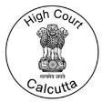

 |  | Power Utilities | Electricity Dept A&N | 36 | Technical & Admin Staff | https://andaman.gov.in/ | 
 |  | Municipal | Municipal Council | 37 | Sanitary Inspector / Clerk | https://andaman.gov.in/ | 
 |  | Postal | India Post | 38 | GDS / Postal Assistant | https://indiapostgdsonline.gov.in/ | 
 |  | Defence | Indian Armed Forces | 39 | Agniveer (Army/Navy/Air Force) | https://www.joinindianarmy.nic.in  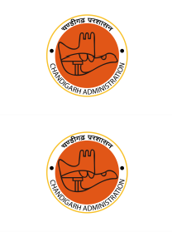  / | 
 |  | Disaster Management | A&N Administration | 40 | Civil Defence / Disaster Volunteers | https://andaman.gov.in/ | 
2 | CHANDIGARH | Administrative | Chandigarh Administration | 1 | Combined Graduate Level Recruitment | https://chandigarh.gov.in/
 |  |  | Chandigarh Administration | 2 | LDC / UDC / JSA / Stenographer | https://chandigarh.gov.in/
 |  | Police | Chandigarh Police | 3 | Constable Recruitment | https://chandigarhpolice.gov.in/ | 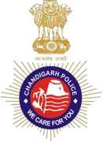
 |  |  | Chandigarh Police | 4 | Sub-Inspector Recruitment | https://chandigarhpolice.gov.in/ | 
 |  | Home Guards | Home Guards Chandigarh | 5 | Home Guard Volunteer | https://chandigarh.gov.in/ | 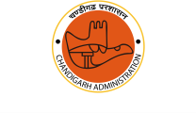

 |  | Teaching | Dept of School Education | 6 | PRT / TGT / PGT Recruitment | 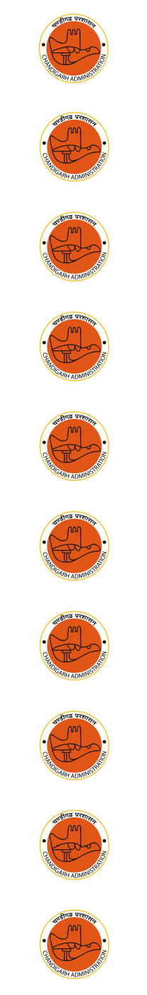  https://chdeducation.gov.in/
 |  |  | Dept of School Education | 7 | Clerk / Assistant / Non-Teaching Staff | https://chdeducation.gov.in/
 |  |  | Govt Colleges Chandigarh | 8 | Assistant Professor / Lecturer | https://dhe.chd.gov.in/
 |  |  | PEC Chandigarh | 9 | Faculty & Non-Teaching Recruitment | https://pec.ac.in/
 |  | Research | CSIR-CSIO | 10 | Technical Assistant / Scientist / Admin | https://www.csio.res.in/
 |  | Medical | Health Dept Chandigarh | 11 | Medical Officer / Specialist | https://chandigarh.gov.in/
 |  |  | Health Dept Chandigarh | 12 | Staff Nurse / Paramedical | https://chandigarh.gov.in/
 |  |  | GMCH-32 | 13 | Nursing Officer / Paramedical / Admin | https://gmch.gov.in/
 |  |  | PGIMER Chandigarh | 14 | Group B/C / Nursing / Technical | https://pgimer.edu.in/
 |  |  | NHM Chandigarh | 15 | Contract Medical & Admin Staff | https://chandigarh.gov.in/

 |  | Engineering | Engineering Dept Chandigarh | 16 | JE / AE (Civil/Electrical) | 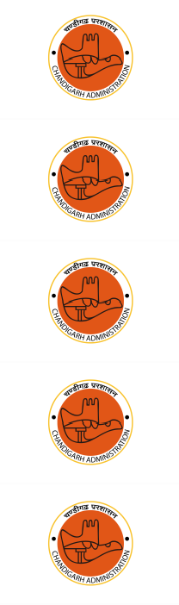  https://chandigarh.gov.in/
 |  | Housing | Chandigarh Housing Board | 17 | JE / Clerk / Admin Staff | https://chandigarhhousingboard.g ov.in/
 |  | Municipal | Municipal Corporation Chandigarh | 18 | Sanitary Inspector / Clerk / JE | https://mcchandigarh.gov.in/
 |  | Transport | Chandigarh Transport Undertaking (CTU) | 19 | Driver / Conductor / Workshop Staff | https://ctuonline.chd.gov.in/
 |  | Power Utilities | Electricity Dept Chandigarh | 20 | Lineman / Technician / JE | https://chandigarh.gov.in/
 |  | Judiciary | District Court Chandigarh | 21 | Clerk / Judicial Assistant / Steno | https://districts.ecourts.gov.in/ | 
 |  |  | Punjab & Haryana High Court | 22 | Court Staff (Chandigarh Cadre) | https://highcourtchd.gov.in/ | 
 |  | Social Welfare | Social Welfare Dept Chandigarh | 23 | Supervisor / Welfare Officer | 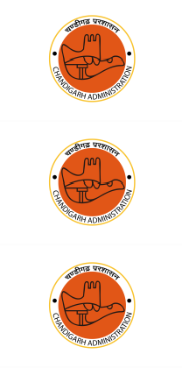  https://chandigarh.gov.in/
 |  | Sports | Sports Dept Chandigarh | 24 | Coach / DSO / Staff | https://chandigarh.gov.in/
 |  | Forest & Wildlife | Forest Dept Chandigarh | 25 | Forest Guard / Staff | https://chandigarh.gov.in/

 |  | Animal Husbandry | Animal Husbandry Dept | 26 | Veterinary Assistant / Staff | 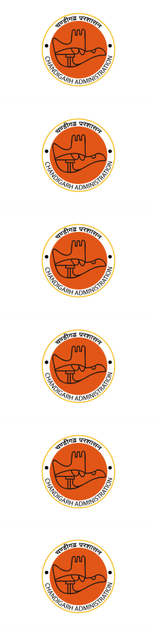  https://chandigarh.gov.in/
 |  | Food & Supplies | Food & Supplies Dept | 27 | Inspector / Clerk | https://chandigarh.gov.in/
 |  | Excise & Taxation | Excise & Taxation Dept | 28 | Inspector / Clerk | https://chandigarh.gov.in/
 |  | Environment | Pollution Control Committee Chandigarh | 29 | Scientist / Analyst | https://pccc.gov.in/
 |  | Census Operations | Office of Census Chandigarh | 30 | Field Investigator / Staff | https://censusindia.gov.in/
 |  | Election Management | Chief Electoral Officer Chandigarh | 31 | Electoral Staff Recruitment | https://ceochandigarh.gov.in/
 |  | Central Govt | SSC | 32 | SSC CGL / CHSL (Chandigarh Cadre) | https://ssc.nic.in/ | 
 |  | Banking | IBPS | 33 | IBPS Clerk / PO / RRB | https://www.ibps.in/ | 
 |  |  | SBI | 34 | SBI PO / Clerk | https://sbi.co.in/web/careers | 
 |  | Postal | India Post | 35 | GDS / Postal Assistant | https://indiapostgdsonline.gov.in/ | 
 |  | Defence | Indian Armed Forces | 36 | Agniveer Recruitment | https://www.joinindianarmy.nic.in  / | 
 |  | Disaster Management | Chandigarh Administration | 37 | Civil Defence / Disaster Volunteers | https://chandigarh.gov.in/ | 

3 | DADRA & NAGAR HAVELI AND DAMAN & DIU | Administrative | UT Administration | 1 | Combined Graduate Level / Administrative Recruitment | https://dnh.gov.in/ | 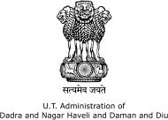
 |  |  | UT Administration | 2 | Lower Division Clerk (LDC) | 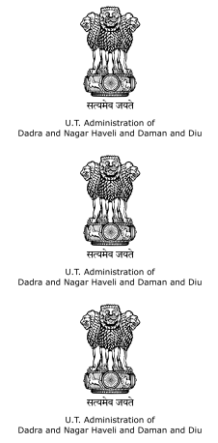  https://dnh.gov.in/
 |  |  | UT Administration | 3 | Upper Division Clerk (UDC) | https://dnh.gov.in/
 |  |  | UT Administration | 4 | Junior Secretariat Assistant / Stenographer | https://dnh.gov.in/
 |  | Police | DNH Police | 5 | Police Constable Recruitment | https://police.dnh.gov.in/ | 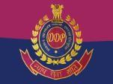
 |  |  | DNH Police | 6 | Sub-Inspector Recruitment | https://police.dnh.gov.in/ | 
 |  | Home Guards | Home Guards & Civil Defence | 7 | Home Guard Volunteer | https://dnh.gov.in/ | 
 |  | Teaching | Education Department | 8 | Primary Teacher (PRT) |   https://dnh.gov.in/
 |  |  | Education Department | 9 | Trained Graduate Teacher (TGT) | https://dnh.gov.in/
 |  |  | Education Department | 10 | Post Graduate Teacher (PGT) | https://dnh.gov.in/

 |  |  | Education Department | 11 | Clerk / Lab Assistant / Non-Teaching Staff | https://dnh.gov.in/ | 
 |  |  | Govt Colleges | 12 | Assistant Professor / Lecturer | 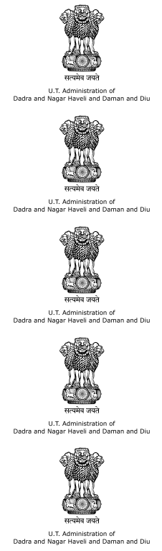  https://dnh.gov.in/
 |  | Medical | Health Department | 13 | Medical Officer / Specialist | https://dnh.gov.in/
 |  |  | Health Department | 14 | Staff Nurse | https://dnh.gov.in/
 |  |  | Health Department | 15 | Pharmacist / Lab Technician / ANM | https://dnh.gov.in/
 |  |  | NHM UT | 16 | Contract Medical & Administrative Staff | https://dnh.gov.in/
 |  | Engineering | Public Works Department (PWD) | 17 | Junior Engineer (Civil/Electrical) | https://dnh.gov.in/ | 
 |  |  | PWD | 18 | Assistant Engineer | 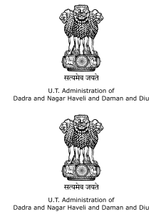  https://dnh.gov.in/
 |  | Utilities | Electricity Department | 19 | Lineman / Technician / JE | https://dnh.gov.in/

 |  | Water Supply | Public Health Engineering | 20 | Technical & Admin Staff | https://dnh.gov.in/ | 
 |  | Municipal | Municipal Council / Local Bodies | 21 | Sanitary Inspector / Clerk |   https://dnh.gov.in/
 |  | Panchayat | District Panchayat | 22 | Panchayat Secretary / Staff | https://dnh.gov.in/
 |  | Environment | Pollution Control Committee | 23 | Scientist / Analyst | https://dnh.gov.in/
 |  | Forest | Forest Department | 24 | Forest Guard / Forester | https://dnh.gov.in/
 |  | Agriculture | Agriculture Department | 25 | Field Assistant / Supervisor | https://dnh.gov.in/
 |  | Animal Husbandry | Animal Husbandry Dept | 26 | Veterinary Assistant / Staff | https://dnh.gov.in/ | 
 |  | Transport | Transport Department | 27 | Motor Vehicle Inspector / Staff | https://dnh.gov.in/ | 
 |  | Judiciary | District Court | 28 | Clerk / Stenographer / Assistant | https://districts.ecourts.gov.in/ | 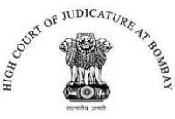

 |  | Social Welfare | Social Welfare Department | 29 | Supervisor / Welfare Officer | https://dnh.gov.in/ | 
 |  | Food & Civil Supplies | Food & Supplies Department | 30 | Inspector / Clerk |   https://dnh.gov.in/
 |  | Excise | Excise Department | 31 | Inspector / Staff | https://dnh.gov.in/
 |  | Central Govt | SSC | 32 | SSC CGL / CHSL (UT Cadre) | https://ssc.nic.in/ | 
 |  | Banking | IBPS | 33 | IBPS Clerk / PO / RRB | https://www.ibps.in/ | 
 |  |  | SBI | 34 | SBI PO / Clerk | https://sbi.co.in/web/careers | 
 |  | Postal | India Post | 35 | GDS / Postal Assistant | https://indiapostgdsonline.gov.in/ | 
 |  | Defence | Indian Armed Forces | 36 | Agniveer Recruitment | https://www.joinindianarmy.nic.in    / | 
 |  | Disaster Management | UT Administration | 37 | Civil Defence / Disaster Volunteers | https://dnh.gov.in/ | 
4 | Jammu & Kashmir | Administrative | JKPSC | 1 | J&K Combined Competitive Examination (CCE/KAS) | https://jkpsc.nic.in/ | 
 |  |  | JKSSB | 2 | JKSSB Graduate Level Examination | https://jkssb.nic.in/
 |  |  | JKSSB | 3 | Junior Assistant | https://jkssb.nic.in/
 |  |  | JKSSB | 4 | Junior Stenographer | https://jkssb.nic.in/ | 
 |  | Engineering Services | JKPSC | 5 | Assistant Engineer (Civil/Electrical/Mechanical) | https://jkpsc.nic.in/ | 

 |  |  | JKSSB | 6 | Junior Engineer |   https://jkssb.nic.in/
 |  | Medical | JKPSC | 7 | Medical Officer | https://jkpsc.nic.in/
 |  |  | JKSSB | 8 | Staff Nurse / Pharmacist / Lab Tech | https://jkssb.nic.in/ | 
 |  |  | JKBOPEE | 9 | BSc Nursing Entrance Exam | https://jkbopee.gov.in/
 |  |  | SKIMS | 10 | Nursing Officer / Technician |     https://skims.ac.in/
 |  |  | AIIMS Jammu | 11 | Group B/C / Nursing | https://aiimsjammu.edu.in/
 |  |  | Govt Medical Colleges | 12 | Paramedical Staff | https://www.gmcs.edu.in/
 |  | Police | J&K Police | 13 | Constable | https://jkpolice.gov.in/ | 
 |  |  | J&K Police | 14 | Sub-Inspector | https://jkpolice.gov.in/ | 
 |  |  | JKSSB | 15 | Sub-Inspector (Home Dept Cadre) | https://jkssb.nic.in/ | 
 |  |  | Home Guards | 16 | Volunteer Recruitment | https://jkhomeguards.nic.in/ | 
 |  | Teaching | JKPSC | 17 | School Lecturer Recruitment |   https://jkpsc.nic.in/ | 
 |  |  | University of Kashmir | 18 | Non-Teaching / Assistant Registrar / Staff | https://www.kashmiruniversity.ne t/
 |  |  | University of Jammu | 19 | Teaching & Non-Teaching Staff | https://www.jammuuniversity.ac.i n/
 |  |  | SKUAST | 20 | Faculty / Technical Staff | https://skuast.org/
 |  | Judiciary | JKPSC | 21 | Assistant Public Prosecutor | https://jkpsc.nic.in/ | 
 |  |  | J&K High Court | 22 | Civil Judge (Junior Division) | https://jkhighcourt.nic.in/ | 
 |  |  | J&K High  Court/District Courts | 23 | Clerk / Stenographer / Assistant | https://jkhighcourt.nic.in/ | 
 |  | Forest | JKSSB | 24 | Forest Guard | https://jkssb.nic.in/ | 
 |  | Professional Entrance | JKBOPEE | 25 | JK Common Entrance Test (Engineering/Medical/Paramedical) | https://jkbopee.gov.in/ | 

 |  | Public Works | PWD J&K | 26 | JE / AE |         https://jkpwd.nic.in/
 |  | Power | J&K Power Corp | 27 | Technician / Lineman | https://jkspdc.nic.in/
 |  | Water | Jal Shakti | 28 | Technical Recruitment | https://jkjalshakti.nic.in/
 |  | Forest | Forest Dept | 29 | Forester / Guard | https://jkforest.gov.in/
 |  | Agriculture | Agriculture Dept | 30 | Agriculture Extension Officer | https://jkagriculture.nic.in/
 |  | Animal Husbandry | AH Dept | 31 | Veterinary Assistant | https://jkah.nic.in/
 |  | Transport | Transport Dept | 32 | Motor Vehicle Inspector | https://jktransport.nic.in/ | 
 |  | Municipal | Urban Local Bodies | 33 | Inspector / Clerk | https://ulbjammu.org/ | 
 |  | Social Welfare | SW Dept | 34 | Supervisor / Welfare Officer | https://jksocialwelfare.nic.in/
 |  | Food | FCS&CA | 35 | Sub Inspector / Assistant |   https://jkfcs.nic.in/
 |  | Disaster | Relief & Rehab | 36 | Civil Defence Volunteer | https://jkrelief.nic.in/ | 
 |  | Central Govt | SSC | 37 | SSC CGL / CHSL | https://ssc.nic.in/ | 
 |  | Banking | IBPS | 38 | IBPS PO / Clerk / RRB | https://www.ibps.in/ | 
 |  |  | SBI | 39 | SBI PO / Clerk | https://sbi.co.in/web/careers | 
 |  | Postal | India Post | 40 | GDS / Postal Assistant | https://indiapostgdsonline.gov.in/ | 
 |  | Defence | Indian Armed Forces | 41 | Agniveer | https://www.joinindianarmy.nic.in  / | 

 |  | Revenue | JKSSB | 42 | Patwari | https://jkssb.nic.in/ | 
 |  | Accounts | JKSSB | 43 | Accounts Assistant |       https://jkssb.nic.in/ | 
5 | Delhi | Teaching | DSSSB | 1 | Primary Teacher (PRT) | https://dsssb.delhi.gov.in/
 |  |  | DSSSB | 2 | Trained Graduate Teacher (TGT) | https://dsssb.delhi.gov.in/
 |  |  | DSSSB | 3 | Post Graduate Teacher (PGT) | https://dsssb.delhi.gov.in/
 |  |  | DSSSB | 4 | Assistant Teacher (Nursery) | https://dsssb.delhi.gov.in/
 |  |  | MCD | 5 | Primary Teacher | https://dsssb.delhi.gov.in/
 |  | Administration | DSSSB | 6 | Lower Division Clerk (LDC) | https://dsssb.delhi.gov.in/ | 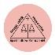
 |  |  | DSSSB | 7 | Upper Division Clerk (UDC) | https://dsssb.delhi.gov.in/ | 
 |  |  | DSSSB | 8 | Assistant Section Officer (ASO) | https://dsssb.delhi.gov.in/ | 
 |  |  | DSSSB | 9 | Junior Secretariat Assistant (JSA) |   https://dsssb.delhi.gov.in/
 |  |  | DSSSB | 10 | Stenographer Grade II/III | https://dsssb.delhi.gov.in/
 |  | Engineering | DSSSB | 11 | Junior Engineer (Civil/Electrical) | https://dsssb.delhi.gov.in/ | 
 |  |  | DSSSB | 12 | Assistant Engineer | https://dsssb.delhi.gov.in/ | 
 |  | Health | DSSSB | 13 | Staff Nurse | https://dsssb.delhi.gov.in/ | 
 |  |  | DSSSB | 14 | Pharmacist | https://dsssb.delhi.gov.in/ | 
 |  |  | DSSSB | 15 | Auxiliary Nurse Midwife (ANM) | https://dsssb.delhi.gov.in/ | 
 |  |  | MCD | 16 | Sanitary Inspector | https://mcdonline.nic.in/ | 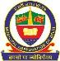
 |  |  | AIIMS Delhi | 17 | Nursing Officer Recruitment | https://www.aiims.edu/en/jobs.ht  ml | 
 |  |  | ESIC | 18 | UDC / Stenographer | https://www.esic.gov.in/recruitm  ents | 

 |  |  | Delhi State Health  Mission | 19 | Contract Medical Staff | https://dshm.delhi.gov.in/ | 
 |  | Police | Delhi Police | 20 | Constable (Executive) | https://delhipolice.gov.in/recruit  ments | 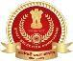
 |  |  | Delhi Police | 21 | Constable (Driver) | https://delhipolice.gov.in/recruit  ments | 
 |  |  | Delhi Police | 22 | Head Constable (Ministerial) | https://delhipolice.gov.in/recruit  ments | 
 |  |  | SSC | 23 | Sub-Inspector (CPO for Delhi Police) | https://ssc.nic.in/ | 
 |  | Judiciary | Delhi High Court | 24 | Delhi Judicial Service (DJS) | https://delhihighcourt.nic.in/web/  job-openings | 
 |  |  | Delhi High Court | 25 | Delhi Higher Judicial Service | https://delhihighcourt.nic.in/web/  job-openings | 
 |  |  | Delhi District Courts | 26 | Judicial Assistant | https://delhidistrictcourts.nic.in/ | 
 |  |  | Delhi District Courts | 27 | Personal Assistant | https://delhidistrictcourts.nic.in/ | 
 |  |  | Directorate of  Education | 28 | Guest Teacher | https://www.edudel.nic.in/ | 
 |  | Municipal  Engineering | MCD | 29 | Junior Engineer | https://mcdonline.nic.in/ | 
 |  | Municipal Health | MCD | 30 | Sanitary Inspector | https://mcdonline.nic.in/ | 
 |  | Municipal Admin | NDMC | 31 | Clerical / Technical Recruitment | https://www.ndmc.gov.in/vacanc  y.aspx | 
 |  | Metro | DMRC | 32 | Station Controller / Train Operator | https://delhimetrorail.com/career  s | 
 |  |  | DMRC | 33 | Customer Relations Assistant | https://delhimetrorail.com/career  s | 
 |  |  | DMRC | 34 | Maintainer | https://delhimetrorail.com/career  s | 
 |  | Transport | DTC | 35 | Driver Recruitment | https://dtc.delhi.gov.in/ | 
 |  |  | DTC | 36 | Conductor Recruitment | https://dtc.delhi.gov.in/ | 
 |  | Water  Engineering | Delhi Jal Board | 37 | Junior Engineer | https://djb.gov.in/ | 
 |  | Environment | DPCC | 38 | Scientist Recruitment | https://dpcc.delhigovt.nic.in/ | 

 |  | Fire Services | Delhi Fire Service | 39 | Fire Operator | https://dfs.delhi.gov.in/ | 
 |  | Prison Services | Delhi Prisons | 40 | Warder Recruitment | https://delhiprisons.nic.in/ | 
 |  | Civil Security | Home Guards | 41 | Home Guard Volunteer | https://homeguards.delhi.gov.in/ | 
 |  | Disaster  Response | Civil Defence | 42 | Civil Defence Volunteer | https://civildefence.delhi.gov.in/ | 
6 | Ladakh | Administrative | UT Ladakh  Administration | 1 | Combined Graduate / Administrative  Recruitment | https://ladakh.nic.in/ | 
 |  |  | UT Ladakh  Administration | 2 | Junior Secretariat Assistant /  Stenographer | https://ladakh.nic.in/ | 
 |  |  | UT Ladakh  Administration | 3 | LDC / UDC | https://ladakh.nic.in/ | 
 |  |  | Ladakh Subordinate Services Recruitment Board  (LSSRB) | 4 | Graduate Level Examination | https://lssrb.ladakh.gov.in/ | 
 |  | Engineering | LSSRB | 5 | Junior Engineer (Civil / Electrical) | https://lssrb.ladakh.gov.in/
 |  | Revenue | LSSRB | 6 | Patwari / Revenue Assistant | https://lssrb.ladakh.gov.in/
 |  | Hill Council | LAHDC Leh | 7 | Clerk / JE / Technical Staff Recruitment | 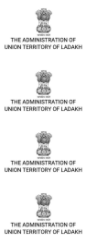  https://leh.nic.in/
 |  |  | LAHDC Kargil | 8 | Clerk / JE / Technical Staff Recruitment | https://kargil.nic.in/
 |  | Police | Ladakh Police | 9 | Constable Recruitment | https://ladakhpolice.nic.in/ | 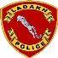
 |  |  | Ladakh Police | 10 | Sub‑Inspector Recruitment | https://ladakhpolice.nic.in/ | 
 |  | Fire Services | Fire & Emergency  Services Ladakh | 11 | Fireman / Driver Operator | https://ladakh.nic.in/ | 
 |  | Home Guards | Home Guards  Ladakh | 12 | Home Guard Volunteer | https://ladakh.nic.in/ | 
 |  | Teaching | School Education  Department | 13 | PRT / TGT / PGT Recruitment | https://ladakh.nic.in/ | 
 |  |  | Govt Degree  Colleges Leh/Kargil | 14 | Assistant Professor / Lecturer | https://ladakh.nic.in/ | 
 |  |  | School Education  Department | 15 | Non‑Teaching Staff Recruitment | https://ladakh.nic.in/ | 
 |  |  | LSSRB | 16 | Laboratory Assistant / Library Assistant | https://lssrb.ladakh.gov.in/

 |  | Medical | Health Department  Ladakh | 17 | Medical Officer / Specialist | https://ladakh.nic.in/ | 
 |  |  | LSSRB | 18 | Staff Nurse / Pharmacist / Technician | https://lssrb.ladakh.gov.in/ | 
 |  |  | Health Department  Ladakh | 19 | Staff Nurse / Paramedical Staff | https://ladakh.nic.in/ | 
 |  |  | NHM Ladakh | 20 | Contract Medical & Administrative Staff | 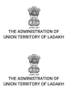  https://ladakh.nic.in/
 |  | Public Works | PWD Ladakh | 21 | Junior Engineer / Assistant Engineer | https://ladakh.nic.in/
 |  | Power | Power Development  Department | 22 | Technician / Lineman / JE | https://ladakh.nic.in/ | 
 |  | Water Supply | Public Health  Engineering Department | 23 | Technical Staff | https://ladakh.nic.in/ | 
 |  | Transport | Transport  Department Ladakh | 24 | Motor Vehicle Inspector / Staff | https://ladakh.nic.in/ | 
 |  | Tourism | Tourism  Department Ladakh | 25 | Tourism Officer / Staff | https://ladakh.nic.in/ | 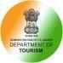
 |  | Forest | Forest Department  Ladakh | 26 | Forest Guard / Forester | https://ladakh.nic.in/ | 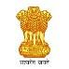
 |  | Environment | Pollution Control  Committee Ladakh | 27 | Scientist / Analyst | https://ladakh.nic.in/ | 
 |  | Rural  Development | Rural Development  Department | 28 | Village Level Worker / Supervisor | https://ladakh.nic.in/ | 
 |  | Agriculture | Agriculture  Department Ladakh | 29 | Agriculture Extension Assistant | https://ladakh.nic.in/ | 
 |  | Animal  Husbandry | Animal & Sheep  Husbandry Dept | 30 | Veterinary Assistant / Staff | https://ladakh.nic.in/ | 
 |  | Judiciary | District Courts  Leh/Kargil | 31 | Clerk / Stenographer / Assistant | https://districts.ecourts.gov.in/ | 
 |  | Social Welfare | Social Welfare  Department | 32 | Supervisor / Welfare Officer | https://ladakh.nic.in/ | 
 |  | Food & Civil  Supplies | Food & Supplies  Department | 33 | Inspector / Assistant | https://ladakh.nic.in/ | 
 |  | Research | DRDO‑DIHAR Leh | 34 | Technical Assistant / Scientist / Admin | https://www.drdo.gov.in/ | 
 |  |  | DRDO‑SASE | 35 | Technical / Scientist Recruitment | https://www.drdo.gov.in/

 |  | Central Govt | SSC | 36 | SSC CGL / CHSL (UT Cadre) | https://ssc.nic.in/ | 
 |  | Banking | IBPS | 37 | IBPS PO / Clerk / RRB | https://www.ibps.in/ | 
 |  |  | SBI | 38 | SBI PO / Clerk | https://sbi.co.in/web/careers | 
 |  | Postal | India Post | 39 | GDS / Postal Assistant | https://indiapostgdsonline.gov.in/ | 
 |  | Defence | Indian Armed Forces | 40 | Agniveer Recruitment | https://www.joinindianarmy.nic.in    / | 
 |  | Disaster Management | UT Disaster Management  Authority | 41 | Civil Defence / Disaster Volunteers | https://ladakh.nic.in/ | 
7 | Lakshadwee p | Administrative | UT Lakshadweep Administration | 1 | Combined Graduate / Administrative Recruitment | https://lakshadweep.gov.in/ | 
 |  |  | Lakshadweep Administration | 2 | LDC / UDC / Junior Secretariat Assistant  / Stenographer | https://lakshadweep.gov.in/
 |  |  | Lakshadweep Administration | 3 | Graduate Level Recruitment | https://lakshadweep.gov.in/
 |  |  | Lakshadweep Administration | 4 | Village Assistant / Revenue Staff | https://lakshadweep.gov.in/
 |  | Police | Lakshadweep Police | 5 | Police Constable Recruitment | https://lakshadweeppolice.gov.in/ | 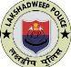
 |  |  | Home Guards  Lakshadweep | 6 | Home Guard Volunteer | https://lakshadweep.gov.in/ | 
 |  | Fire Services | Fire & Emergency Services  Lakshadweep | 7 | Fireman / Driver | https://lakshadweep.gov.in/ | 
 |  | Teaching | Department of Education | 8 | Primary Teacher (PRT) |   https://lakshadweep.gov.in/
 |  |  | Department of Education | 9 | TGT / PGT Recruitment | https://lakshadweep.gov.in/
 |  |  | Education Department | 10 | Lab Assistant / Non-Teaching Staff | https://lakshadweep.gov.in/

 |  |  | Govt Colleges Lakshadweep | 11 | Assistant Professor / Lecturer |     https://lakshadweep.gov.in/
 |  | Medical | Health Services Lakshadweep | 12 | Medical Officer / Specialist | https://lakshadweep.gov.in/
 |  |  | Health Services | 13 | Staff Nurse / Pharmacist / Lab Technician | https://lakshadweep.gov.in/
 |  |  | National Health Mission (NHM) | 14 | Contract Medical & Administrative Staff | https://lakshadweep.gov.in/
 |  | Engineering | Public Works Department | 15 | Junior Engineer / Assistant Engineer | https://lakshadweep.gov.in/
 |  | Electricity | Electricity Department | 16 | Technician / Lineman | https://lakshadweep.gov.in/
 |  | Water Supply | Public Health Engineering | 17 | Technical Staff | https://lakshadweep.gov.in/
 |  | Fisheries | Department of  Fisheries | 18 | Fisheries Inspector / Field Assistant | https://lakshadweep.gov.in/ | 
 |  | Marine | Lakshadweep Development  Corporation (LDCL) | 19 | Crew / Technical / Administrative Staff | https://ldcl.nic.in/ | 
 |  | Shipping | Directorate of Shipping Services | 20 | Marine Staff / Seaman | https://lakshadweep.gov.in/ | 
 |  | Environment | Department of Environment &  Forest | 21 | Forest Guard / Forester | https://lakshadweep.gov.in/ | 
 |  | Agriculture | Department of Agriculture | 22 | Agriculture Field Assistant |   https://lakshadweep.gov.in/
 |  | Animal Husbandry | Animal Husbandry Department | 23 | Veterinary Assistant | https://lakshadweep.gov.in/
 |  | Judiciary | District Court Lakshadweep | 24 | Clerk / Stenographer / Assistant | https://districts.ecourts.gov.in/
 |  | Social Welfare | Social Welfare Department | 25 | Supervisor / Welfare Officer | https://lakshadweep.gov.in/ | 
 |  | Food & Civil Supplies | Food & Supplies Department | 26 | Inspector / Assistant | https://lakshadweep.gov.in/ | 

 |  | Tourism | Tourism  Department | 27 | Tourism Officer / Staff | https://lakshadweep.gov.in/ | 
 |  | Disaster Management | UT Disaster Management  Authority | 28 | Civil Defence / Disaster Volunteers | https://lakshadweep.gov.in/ | 
 |  | Central Govt | SSC | 29 | SSC CGL / CHSL (UT Cadre) | https://ssc.nic.in/ | 
 |  | Banking | IBPS | 30 | IBPS PO / Clerk / RRB | https://www.ibps.in/ | 
 |  |  | SBI | 31 | SBI PO / Clerk | https://sbi.co.in/web/careers | 
 |  | Postal | India Post | 32 | GDS / Postal Assistant | https://indiapostgdsonline.gov.in/ | 
 |  | Defence | Indian Armed Forces | 33 | Agniveer Recruitment | https://www.joinindianarmy.nic.in  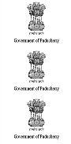    / | 
8 | Puducherry | Administrative | Government of  Puducherry | 1 | Combined Graduate / Administrative  Recruitment | https://www.py.gov.in/ | 
 |  |  | Government of  Puducherry | 2 | LDC / UDC / Junior Secretariat Assistant  / Stenographer | https://www.py.gov.in/ | 
 |  |  | Puducherry Subordinate Services Selection  Board (PSSSB) | 3 | Graduate Level Recruitment | https://recruitment.py.gov.in/ | 
 |  |  | PSSSB | 4 | Junior Assistant / Clerk | https://recruitment.py.gov.in/
 |  | Engineering | PSSSB | 5 | Junior Engineer (Civil/Electrical) | https://recruitment.py.gov.in/
 |  | Health | PSSSB | 6 | Staff Nurse / Pharmacist / Technician | https://recruitment.py.gov.in/
 |  | Police | Puducherry Police | 7 | Police Constable Recruitment | https://police.py.gov.in/
 |  |  | Puducherry Police | 8 | Sub-Inspector Recruitment | https://police.py.gov.in/
 |  | Fire Services | Fire & Emergency  Services Puducherry | 9 | Fireman / Driver Operator | https://www.py.gov.in/ | 
 |  | Home Guards | Home Guards  Puducherry | 10 | Home Guard Volunteer | https://www.py.gov.in/ | 
 |  | Teaching | School Education | 11 | PRT / TGT / PGT Recruitment | https://schooleducation.py.gov.in | 

 |  |  | Department |  |  | /
 |  |  | School Education  Department | 12 | Non-Teaching Staff | https://schooleducation.py.gov.in  / | 
 |  |  | Government  Colleges Puducherry | 13 | Assistant Professor / Lecturer | https://highereducation.py.gov.in  / | 
 |  |  | Pondicherry  University | 14 | Teaching & Non-Teaching Staff | https://www.pondiuni.edu.in/ | 
 |  |  | Puducherry Technological  University (PTU) | 15 | Faculty / Technical Staff | https://ptuniv.edu.in/ | 
 |  | Medical | Health Department  Puducherry | 16 | Medical Officer / Specialist | https://health.py.gov.in/ | 
 |  |  | Health Department  Puducherry | 17 | Staff Nurse / Paramedical Staff | https://health.py.gov.in/ | 
 |  |  | JIPMER | 18 | Group B/C / Nursing / Technical | 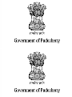  https://jipmer.edu.in/
 |  |  | NHM Puducherry | 19 | Contract Medical & Administrative Staff | https://health.py.gov.in/
 |  | Public Works | Public Works  Department | 20 | Junior Engineer / Assistant Engineer | https://pwd.py.gov.in/ | 
 |  | Power | Electricity Department  Puducherry | 21 | Technician / Lineman / JE | https://electricity.py.gov.in/ | 
 |  | Water Supply | Public Health Engineering  Department | 22 | Technical Staff | https://pwd.py.gov.in/ | 
 |  | Transport | Transport Department  Puducherry | 23 | Motor Vehicle Inspector / Staff | https://transport.py.gov.in/ | 
 |  | Ports & Shipping | Port Department  Puducherry | 24 | Port Staff / Technical Recruitment | https://ports.py.gov.in/ | 
 |  | Environment | Pollution Control  Committee Puducherry | 25 | Scientist / Analyst | https://pcc.py.gov.in/ | 
 |  | Forest | Forest Department  Puducherry | 26 | Forest Guard / Forester | https://forest.py.gov.in/ | 
 |  | Agriculture | Agriculture  Department Puducherry | 27 | Agriculture Extension Assistant | https://agriculture.py.gov.in/ | 
 |  | Animal | Animal Husbandry | 28 | Veterinary Assistant / Staff | https://ah.py.gov.in/ | 

 |  | Husbandry | Department
 |  | Rural  Development | RD & Panchayat Raj  Department | 29 | Village Level Worker / Supervisor | https://rd.py.gov.in/ | 
 |  | Judiciary | District Court  Puducherry | 30 | Clerk / Stenographer / Assistant | https://districts.ecourts.gov.in/ | 
 |  | Social Welfare | Social Welfare  Department | 31 | Supervisor / Welfare Officer | https://socialwelfare.py.gov.in/ | 
 |  | Food & Civil  Supplies | Food & Supplies  Department | 32 | Inspector / Assistant | https://civil supplies.py.gov.in | 
 |  | Tourism | Tourism Department  Puducherry | 33 | Tourism Officer / Staff | https://tourism.py.gov.in/ | 
 |  | Disaster Management | UT Disaster Management  Authority | 34 | Civil Defence / Disaster Volunteers | https://www.py.gov.in/ | 
 |  | Central Govt | SSC | 35 | SSC CGL / CHSL (UT Cadre) | https://ssc.nic.in/ | 
 |  | Banking | IBPS | 36 | IBPS PO / Clerk / RRB | https://www.ibps.in/ | 
 |  |  | SBI | 37 | SBI PO / Clerk | https://sbi.co.in/web/careers | 
 |  | Postal | India Post | 38 | GDS / Postal Assistant | https://indiapostgdsonline.gov.in/ | 
 |  | Defence | Indian Armed Forces | 39 | Agniveer Recruitment | https://www.joinindianarmy.nic.in  / | 

